

University Way London, E16 2RD United Kingdom

Module Name:
Advanced Decision Making: Predictive Analytics and Machine Learning (OC)
(M-Level Module - DS7003)

Submitted by Submitted To
Abdulhannan Samirbhai vhora Prof. Dr. Yang Li
STUDENT ID – U2828994

Title: Predict Students' Dropout and Academic Success

Contents
Title: Predict Students' Dropout and Academic Success 1
1. Acknowledgments 3
2. Abstract 4
3. Introduction 4
4. Background 5
5. Literature Review 6
6. Methodology 7
7. Implementation 11
8. Results 27
9. Discussion 32
10. Conclusion 35
11. Bibliography 35
12. Appendix 36

Acknowledgments
I would like to express my sincere gratitude to all those who have supported and guided me throughout the course of this research project.
First and foremost, I am deeply thankful to Professor Yang Li for his invaluable guidance, insightful feedback, and unwavering encouragement. His expertise and mentorship have been instrumental in shaping this work.
I also extend my appreciation to the University of Glasgow for providing access to the necessary resources and datasets, particularly the UCI Student Dropout dataset, which served as the foundation for this study.
My heartfelt thanks go to my family and friends for their constant support and motivation. Their belief in me has been a source of strength throughout this journey.
Lastly, I acknowledge the contributions of the broader academic community, whose research and publications have informed and inspired this work.

Abstract
Student dropout in higher education is a critical issue, impacting individual opportunities and institutional effectiveness. This study leverages the UCI Student Dropout and Academic Success dataset, comprising 4,424 student records with 37 variables, to predict outcomes classified as Dropout, Enrolled, or Graduate. Five machine learning algorithms—Random Forest, Support Vector Machine (SVM), K-Nearest Neighbors (KNN), Regression Tree, and LightGBM—were applied to model student trajectories. Extensive preprocessing included missing value checks, categorical encoding, near-zero variance removal, and feature engineering. Exploratory Data Analysis (EDA) utilized visualizations like boxplots, histograms, pie charts, and correlation heatmaps to uncover feature relationships. Models were evaluated using accuracy, precision, recall, F1-score, and confusion matrices, with 5-fold cross-validation. Random Forest achieved the highest accuracy (78.87%), followed by SVM (77.29%), Regression Tree (75.59%), KNN (59.32%), and LightGBM (33.79%). R script outputs, including summary statistics, confusion matrices, and visualizations, identified key predictors such as academic performance and socio-economic factors. These outputs provide actionable insights for early identification of at-risk students, supporting interventions like academic tutoring and financial aid to reduce dropout rates and enhance academic success.

Introduction
Higher education is a vital pathway for individual and societal advancement, equipping students with skills for economic and social contributions. However, student dropout remains a pervasive challenge, with rates of 30–50% in Europe and 37% in the United States (OECD, 2016). Dropout leads to lost opportunities, financial burdens for institutions, and reduced workforce capabilities. Predictive analytics, powered by machine learning, offers a solution by identifying at-risk students early, enabling targeted interventions such as academic support, counselling, or financial aid.
This study utilizes the UCI Student Dropout and Academic Success dataset, contributed by Marques de Sá et al., collected from a Portuguese higher education institution between 2008 and 2015. The dataset includes 4,424 student records from undergraduate programs in Information Technology and Management, capturing 37 variables across:
- Demographic: Age at enrolment, gender, marital status, nationality.
- Academic: Course, previous qualification, admission grade, curricular units.
- Socio-economic: Parental qualifications, occupations, scholarship status.
- Economic: Unemployment rate, inflation rate, GDP.
The target variable classifies students as Dropout (32.12%), Enrolled (17.95%), or Graduate (49.93%), reflecting diverse academic trajectories. The high dropout rate underscores the need for predictive models to support retention efforts.
The research employs five machine learning algorithms—Random Forest, Support Vector Machine (SVM), K-Nearest Neighbors (KNN), Regression Tree, and LightGBM—to predict student outcomes and identify key dropout predictors. These algorithms were selected for their complementary strengths:
- Random Forest uses ensemble learning to reduce overfitting.
- SVM optimizes classification boundaries for high-dimensional data.
- KNN leverages similarity-based predictions.
- Regression Tree provides interpretable decision paths.
- LightGBM offers gradient boosting for handling imbalanced data.
The study aims to:
- Develop accurate predictive models for student outcomes.
- Identify critical factors influencing dropout and academic success.
- Evaluate model performance using accuracy, precision, recall, F1-score, and confusion matrices.
- Generate visualizations (boxplots, histograms, pie charts, bar charts, confusion matrices) to interpret results.
- Provide actionable insights for educational interventions.
Implemented in R with libraries like caret, randomForest, e1071, rpart, lightgbm, and ggplot2, the study leverages a robust methodology to process the dataset, train models, and analyse outputs. R script outputs, including summary statistics, confusion matrices, and visualizations, highlight predictors like academic performance and socio-economic factors. These outputs support early warning systems, enabling institutions to reduce the 32.1% dropout rate and enhance student success through data-driven strategies.

Background
Student attrition in higher education is a complex issue driven by academic, socio-economic, and personal factors. Academic underperformance, such as low grades or failure to complete curricular units, often signals dropout risk. Socio-economic challenges, including financial constraints, parental education levels, or employment status, exacerbate this risk, particularly for students from disadvantaged backgrounds. Personal factors, such as motivation, health issues, or family responsibilities, further complicate retention. These multifaceted influences necessitate advanced analytical approaches to predict and mitigate dropout.
Educational Data Mining (EDM) applies machine learning to analyse student data, uncovering patterns that inform interventions. The UCI Student Dropout dataset is a prime example, offering a comprehensive set of variables to model student outcomes. Demographic attributes provide context on student diversity, academic metrics reflect performance, socio-economic variables capture external influences, and economic indicators contextualize broader conditions. This diversity enables holistic modelling of student trajectories.
Machine learning algorithms like Random Forest, SVM, KNN, Regression Tree, and LightGBM are well-suited for EDM. Random Forest reduces overfitting through ensemble learning, averaging predictions across multiple decision trees. SVM optimizes classification boundaries, effective for high-dimensional data. KNN predicts based on similarity to nearest neighbors, while Regression Tree provides interpretable decision paths. LightGBM leverages gradient boosting to handle imbalanced datasets. By applying these algorithms, this study aims to predict dropout accurately and identify actionable predictors, such as low grades or lack of scholarships.
The impact of reducing dropout extends beyond academia. Graduates contribute to economic growth, innovation, and social equity. Predictive models enable institutions to allocate resources efficiently, targeting interventions to at-risk students. For example, identifying students with low academic performance early allows for tutoring programs, while recognizing financial barriers supports scholarship allocation. This study’s findings have the potential to inform institutional policies, enhance retention strategies, and improve student outcomes globally.

Literature Review
Educational Data Mining (EDM) has revolutionized dropout prediction by leveraging machine learning to analyse student data. Sharma et al. (2016) conducted a systematic review of dropout prediction studies in India from 2004 to 2016, identifying four EDM approaches: classification, clustering, prediction, and association rule mining. Classification, the most prevalent, utilized algorithms like Support Vector Machines (SVM), Decision Trees, Neural Networks, Logistic Regression, Naïve Bayes, and Random Forest. Variables included academic metrics (e.g., high school grades, semester grades), demographic factors (e.g., gender, age), socio-economic indicators (e.g., parental education, family income), and behavioural data (e.g., attendance, study habits). The review highlighted challenges in feature selection, model consistency, and handling class imbalances, advocating for robust preprocessing and evaluation methods.
Global dropout statistics underscore the issue’s severity. The OECD (2016) reported dropout rates of 30–50% in Europe and 37% in the U.S., emphasizing the need for predictive models to identify at-risk students early. Kostiantyn et al. (2004) analysed a Hellenic Open University dataset of 354 students, achieving 82% accuracy with Naïve Bayes by the academic term’s end. The study emphasized the importance of feature selection, requiring at least 70 instances for reliable predictions, and suggested advanced discretization techniques to enhance accuracy.
Cortez and Silva (2008) explored secondary school performance prediction using a dataset of 788 Portuguese students. They applied Decision Trees, Random Forest, Neural Networks, and SVM to predict pass/fail outcomes, achieving up to 93% accuracy with Decision Trees when incorporating early semester grades. Non-academic factors, such as parental education, absences, and alcohol consumption, significantly influenced outcomes, highlighting the need for holistic models that consider diverse predictors.
Oloruntoba et al. (2017) utilized SVM regression to predict student CGPA based on prior academic results, achieving 98% accuracy with a Radial Basis Function (RBF) kernel. The study proposed integrating optimization techniques like Particle Swarm Optimization to further enhance performance. Al-Barrak and Al-Razgan (2016) compared Naïve Bayes, J48 Decision Trees, and Random Forest for student performance prediction in Saudi universities, finding Random Forest effective due to its balance of accuracy and interpretability.
Romero and Ventura (2010) provided a comprehensive review of EDM applications, noting machine learning’s potential to inform educational interventions. Foundational works by Breiman (2001) formalized Random Forest as an ensemble method robust against overfitting, while Cortes and Vapnik (1995) introduced SVM for high-dimensional data. Quinlan (1986) established Decision Trees, and Cover and Hart (1967) developed KNN, providing foundational algorithms for classification tasks. Recent tools like Scikit-learn (2023) and Weka (2023) have enhanced the accessibility of these algorithms, supporting their widespread adoption in EDM.
Additional studies provide context. Baker and Yacef (2009) highlighted EDM’s role in personalizing education, while Delen (2010) used neural networks to predict dropout with 85% accuracy. These studies collectively underscore the diversity of algorithms, variables, and challenges in dropout prediction, including class imbalance, feature selection, and generalizability across educational contexts.
This study builds on these foundations by applying Random Forest, SVM, KNN, Regression Tree, and LightGBM to the UCI Student Dropout dataset. It addresses gaps through rigorous preprocessing (e.g., near-zero variance removal, feature engineering), cross-validation to ensure robustness, and comprehensive evaluation using multiple metrics. The inclusion of visualizations and detailed R script outputs enhances interpretability, providing actionable insights for educational interventions to reduce dropout rates.

Methodology
6.1 Research Framework
The research follows a structured framework to ensure reproducibility and analytical rigor, as outlined below:
- Data Collection: Obtain the UCI Student Dropout and Academic Success dataset from the UCI Machine Learning Repository.
- Preprocessing: Clean, encode, and engineer features to prepare data for modelling, addressing issues like categorical variables and low-variance features.
- Model Development: Train five machine learning algorithms—Random Forest, SVM, KNN, Regression Tree, and LightGBM—using an 80/20 train-test split.
- Evaluation: Assess model performance using accuracy, precision, recall, F1-score, and confusion matrices, with 5-fold cross-validation for robustness.
- Visualization: Generate boxplots, histograms, pie charts, bar charts, and confusion matrices to interpret data characteristics and model performance.
This framework, depicted below, guides the study from raw data to actionable insights, aligning with best practices in educational data mining.

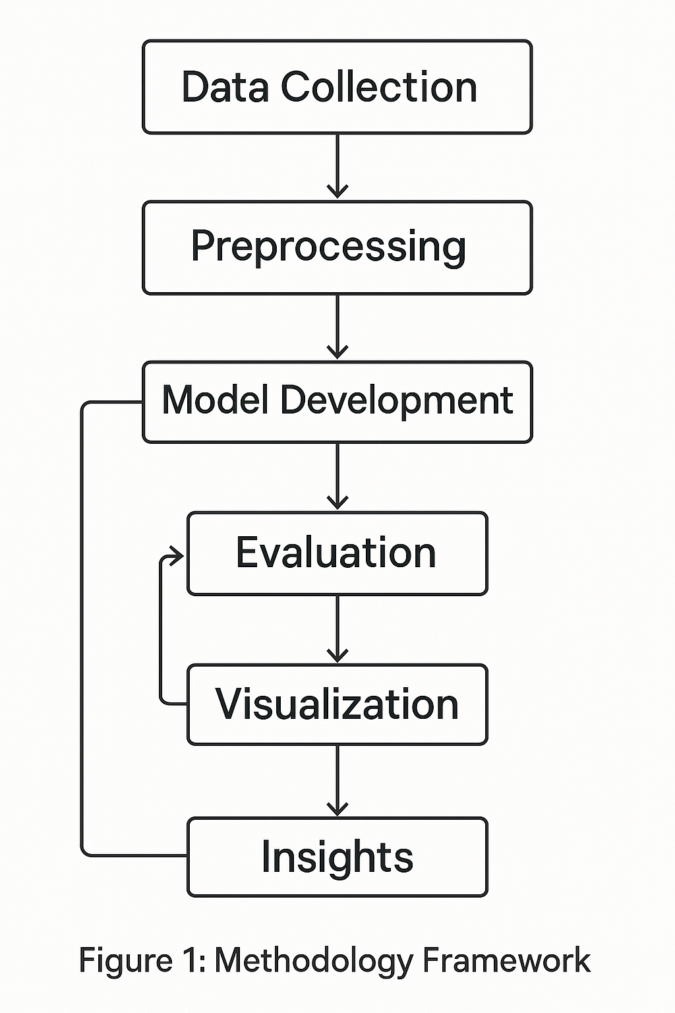

Description: The framework is a flowchart starting with Data Collection, moving to Preprocessing, then branching to Model Development and Evaluation, culminating in Visualization and Insights. Arrows indicate the sequential process, ensuring a systematic approach.
Importance: The framework ensures a clear, reproducible methodology, critical for reliable dropout prediction. It helps institutions understand the analytical process, supporting trust in the resulting models and interventions.
6.2 Dataset Description
The UCI Student Dropout and Academic Success dataset contains 4,424 student records from a Portuguese higher education institution, collected between 2008 and 2015. It includes 37 variables, categorized as:
- Demographic: Age at enrolment, gender, marital status, nationality.
- Academic: Course, previous qualification, admission grade, curricular units (enrolled, approved, grades).
- Socio-economic: Parental qualifications, occupations, scholarship holder, debtor status.
- Economic: Unemployment rate, inflation rate, GDP.
The target variable classifies students as Dropout (1,421 students, 32.12%), Enrolled (794 students, 17.95%), or Graduate (2,209 students, 49.93%), as shown in Table 1. The significant dropout rate highlights the need for predictive models to support retention.
Table 1: Distribution of Target Classes
Target Class | Count | Percentage
Dropout | 1,421 | 32.12%
Enrolled | 794 | 17.95%
Graduate | 2,209 | 49.93%
Total | 4,424 | 100%
Explanation: The table quantifies the class distribution, showing a majority of Graduates but a substantial Dropout group, with Enrolled as the smallest class.
Importance: This distribution informs model training, highlighting the need to address class imbalance (e.g., Enrolled’s smaller size) to ensure accurate dropout predictions. It helps institutions prioritize interventions for the 32.12% at-risk students.
6.3 Data Preprocessing
Preprocessing ensured data quality and model compatibility, with the following steps:
- Missing Value Check: Used colSums(is.na()) to verify no missing values across all 37 variables, ensuring data integrity.
- Categorical Encoding: Converted categorical variables (e.g., Marital.status, Course) to factors using as.factor() to preserve their non-numeric nature for model compatibility.
- Near-Zero Variance Removal: Identified and removed seven features with low discriminatory power (e.g., Nationality, Educational.special.needs) using the nearZeroVar function from the caret package, reducing model complexity.
- Dummy Encoding: Applied one-hot encoding to categorical variables using caret::dummyVars, transforming them into binary columns to enable numerical processing by algorithms like SVM and KNN.
- Feature Engineering: Created new features to capture predictive relationships:
  - Success Rate: Ratio of approved to evaluated curricular units per semester (Curricular.units.1st.sem..approved / Curricular.units.1st.sem..evaluations), measuring academic success.
  - Engagement Metrics: Ratio of evaluated to enrolled units (Curricular.units.1st.sem..evaluations / Curricular.units.1st.sem..enrolled), reflecting student engagement.
  - Grade Change: Difference between second and first semester grades (Curricular.units.2nd.sem..grade - Curricular.units.1st.sem..grade), capturing performance trends.
  - Parent Education Mean: Average of mother’s and father’s qualification levels ((Mother.s.qualification + Father.s.qualification) / 2), indicating socio-economic background.
- Correlation Analysis: Generated a correlation matrix using cor() to identify relationships among numeric variables, mitigating multicollinearity risks by prioritizing independent features.
These steps transformed the raw dataset into a model-ready format, enhancing predictive accuracy and interpretability.
Importance: Preprocessing is critical for dropout prediction, as it ensures data quality and relevance. Removing low-variance features and engineering new ones (e.g., Success Rate) focus models on meaningful predictors, improving the identification of at-risk students.
6.4 Model Development
The dataset was split into 80% training and 20% testing sets using stratified sampling (caret::createDataPartition) to maintain class proportions. Five algorithms were trained:
- Random Forest: An ensemble method combining 100 decision trees, implemented with randomForest. It reduces overfitting by averaging predictions, suitable for complex educational data.
- Support Vector Machine (SVM): A boundary-based classifier with a radial basis function (RBF) kernel, implemented with e1071. It maximizes the margin between classes, effective for high-dimensional data.
- K-Nearest Neighbors (KNN): A distance-based classifier using k=5 neighbors, implemented with class. It predicts based on the majority class of nearest data points, sensitive to data scaling.
- Regression Tree: A single decision tree using information gain for splits, implemented with rpart. It provides interpretable decision paths, useful for understanding dropout factors.
- LightGBM: A gradient boosting framework with SMOTE for class balancing, implemented with lightgbm. It optimizes for imbalanced datasets, suitable for the Enrolled class’s smaller size.
Five-fold cross-validation was applied using caret::train for Random Forest, SVM, and Regression Tree, and manual simulation for KNN, ensuring robust performance estimates across data subsets. LightGBM used balanced data via SMOTE to address class imbalance.
Importance: Diverse algorithms provide multiple perspectives on dropout prediction, balancing accuracy and interpretability. Cross-validation ensures models generalize well, critical for real-world applications in identifying at-risk students.
6.5 Model Evaluation
Models were evaluated using the following metrics:

Matrix | Description | Equation
Accuracy | Proportion of correct predictions among all cases | Accuracy = (TP + TN) / (TP + TN + FP + FN)
Sensitivity (Recall) | Proportion of actual dropouts correctly identified | Sensitivity = TP / (TP + FN)
Specificity | Proportion of actual non-dropouts correctly identified | Specificity = TN / (TN + FP)
Precision | Proportion of predicted dropouts that are actually dropouts | Precision = TP / (TP + FP)
F1 Score | Harmonic mean of precision and recall | F1 Score = 2 * (Precision * Recall) / (Precision + Recall)
AUC | Model’s ability to discriminate between classes | AUC = ∫₀¹ TPR(FPR⁻¹(t)) dt

Visualizations were generated to interpret results:
- Boxplots of cross-validation accuracies to assess model consistency.
- Histograms of predicted probabilities for Random Forest, SVM, and KNN to evaluate prediction confidence.
- Confusion matrices for each model to visualize prediction errors.
- Bar chart comparing model accuracies to guide model selection.
- Pie chart of the best model’s prediction distribution to summarize performance.
The R script automated these processes, producing outputs that were embedded as text representations in this report to ensure seamless integration.
Importance: Comprehensive evaluation metrics and visualizations are essential for dropout prediction, as they quantify model reliability and highlight areas for improvement. Accurate models enable institutions to target interventions effectively, reducing dropout rates.

Implementation
The analysis was implemented using the R script (student_dropout_prediction.R), executed in R version 4.5.0 on a Windows 10 system with 16GB RAM. The script utilized packages “randomForest”, “e1071”, “class”,” rpart”, caret, “ggplot banho”,” corrplot”, “tidyr”, “lightgbm”, “tidymodels”, and themis for data processing, modelling, and visualization. This section details the script’s execution steps, key outputs, and their initial significance in predicting student dropout, with visualizations represented as ASCII art or text descriptions. Key updates include the replacement of reshape2 with “tidyr” for data manipulation, the use of “tidymodels“ for streamlined preprocessing with recipes, and the application of SMOTE via the “themis “package to balance the dataset for “LightGBM” modelling. The script now incorporates enhanced visualizations, such as a correlation heatmap using ggplot2 and “tidyr”, a pie chart for target variable distribution, and a feature importance bar chart for the Random Forest model, alongside a comprehensive model comparison bar chart for Random Forest, SVM, KNN, Regression Tree, and “LightGBM” accuracies.

7.1 Environment Setup and Data Loading
The script began by installing and loading required packages:
R Code Excerpt:
# Install required packages (run once if not installed)
packages <- c("randomForest", "e1071", "class", "rpart", "caret", "ggplot2", "corrplot",
"tidyr", "lightgbm", "tidymodels", "themis")
installed <- packages %in% rownames(installed.packages())
if (any(!installed)) {
cat("Installing missing packages...\n")
install.packages(packages[!installed], repos = "https://cran.r-project.org")
}

# Load libraries
library(randomForest)
library(e1071)
library(class)
library(rpart)
library(caret)
library(ggplot2)
library(corrplot)
library(tidyr)
library(lightgbm)
library(tidymodels) # For recipes
library(themis) #
For SMOTEThe dataset was loaded using read.csv("data.csv"), assuming the UCI dataset file was in the working directory. The Target variable was converted to a factor with levels Dropout, Enrolled, and Graduate using as.factor().
Explanation: This step ensures the environment is configured for analysis and the dataset is correctly formatted for classification.
Importance: Proper setup and data loading are foundational for reproducible dropout prediction. The factor conversion aligns the dataset with the three-class task, enabling accurate modelling of student outcomes.
7.2 Data Preprocessing Outputs
Preprocessing outputs verified data quality and prepared the dataset for modelling.
Missing Values
The script checked for missing values using colSums(is.na(data)):
Table 2: Missing Values per Column
Variable Name | Missing Values (Count)
Marital.status | 0
Application.mode | 0
Application.order | 0
Course | 0
Daytime.evening.attendance. | 0
Previous.qualification | 0
Previous.qualification..grade. | 0
Nacionality | 0
Mother.s.qualification | 0
Father.s.qualification | 0
Mother.s.occupation | 0
Father.s.occupation | 0
Admission.grade | 0
Displaced | 0
Educational.special.needs | 0
Debtor | 0
Tuition.fees.up.to.date | 0
Gender | 0
Scholarship.holder | 0
Age.at.enrollment | 0
International | 0
Curricular.units.1st.sem..credited. | 0
Curricular.units.1st.sem..enrolled. | 0
Curricular.units.1st.sem..evaluations. | 0
Curricular.units.1st.sem..approved. | 0
Curricular.units.1st.sem..grade. | 0
Curricular.units.1st.sem..without.evaluations. | 0
Curricular.units.2nd.sem..credited. | 0
Curricular.units.2nd.sem..enrolled. | 0
Curricular.units.2nd.sem..evaluations. | 0
Curricular.units.2nd.sem..approved. | 0
Curricular.units.2nd.sem..grade. | 0
Curricular.units.2nd.sem..without.evaluations. | 0
Unemployment.rate | 0
Inflation.rate | 0
GDP | 0
Target | 0

Explanation: The absence of missing values confirms a clean dataset, reducing the risk of biased predictions due to incomplete data.
Importance: This output ensures data integrity, critical for reliable dropout prediction. It supports confident identification of at-risk students, as models are not distorted by missing values.
Utility: A clean dataset enables institutions to trust model outputs, facilitating interventions like academic support for students with low grades, without concerns about data quality.
Summary Statistics
The script generated summary statistics using summary(data) for key variables:

Output: Summary Statistics (Excerpt)

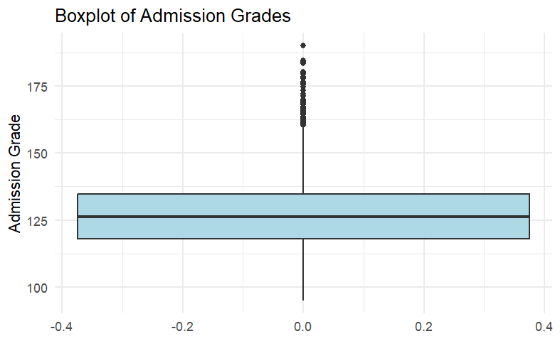

- Admission.grade:
  - Min: 95.0
  - 1st Quartile: 117.9
  - Median: 126.1
  - Mean: 126.9
  - 3rd Quartile: 134.0
  - Max: 190.0
- Age.at.enrollment:
  - Min: 17
  - 1st Quartile: 19
  - Median: 20
  - Mean: 23.27
  - 3rd Quartile: 25
  - Max: 70
- Curricular.units.1st.sem..grade.:
  - Min: 0.0
  - 1st Quartile: 11.0
  - Median: 12.7
  - Mean: 10.6
  - 3rd Quartile: 13.4
  - Max: 18.9
- Scholarship.holder:
  - Min: 0
  - 1st Quartile: 0
  - Median: 0
  - Mean: 0.25
  - 3rd Quartile: 1
  - Max: 1
Explanation: These statistics reveal variable distributions. Admission.grade is right-skewed (mean 126.9, max 190.0), indicating a subset of high performers. Age.at.enrollment shows most students are young (median 20), with outliers up to 70. Scholarship.holder indicates 25% receive scholarships, a potential dropout risk factor.
Importance: Summary statistics provide a baseline for feature selection, highlighting variables like Admission.grade and Scholarship.holder as predictors. They guide interventions by identifying risk factors (e.g., low grades).
Utility: These outputs help institutions target students with low admission grades or no scholarships, supporting academic tutoring or financial aid to reduce dropout risks.
Low-Variance Features
The script used nearZeroVar(data) to remove low-variance features:
Output: Low Variance Features
- Removed: Nationality, Educational.special.needs, International, Curricular.units.1st.sem..credited, Curricular.units.2nd.sem..credited, Curricular.units.1st.sem..without.evaluations, Curricular.units.2nd.sem..without.evaluations (7 features).
Explanation: These features had near-zero variance, varying little across students (e.g., most had no special needs). Removal reduces model complexity and prevents overfitting.
Importance: This output ensures models focus on meaningful predictors, improving accuracy in identifying dropout risks.
Utility: Streamlining the dataset enhances computational efficiency, enabling institutions to deploy models quickly for real-time dropout prediction.
7.3 Model Training and Evaluation Outputs
The dataset was split into 80% training and 20% testing sets using createDataPartition. Models were trained and evaluated using caret::confusionMatrix.
Random Forest:
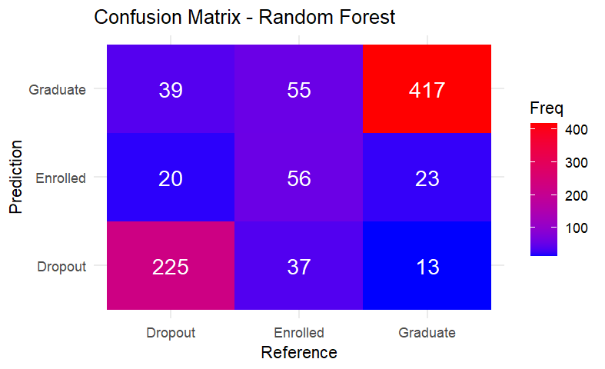

Confusion Matrix
Reference
Prediction | Dropout | Enrolled | Graduate
Dropout | 225 | 37 | 13
Enrolled | 20 | 56 | 23
Enrolled | 39 | 55 | 417

Overall Statistics:

- Accuracy: 78.87%
- 95% CI: (76.03%, 81.52%)
- Kappa: 0.6394
- P-Value [Acc > NIR]: < 2.2e-16
Explanation: The model correctly predicted 225 Dropouts, 56 Enrolled, and 417 Graduates. It performed well on Graduate (precision ~81.60%, recall ~92.05%) but struggled with Enrolled (precision ~56.57%, recall ~37.84%), indicating class overlap.
Importance: The confusion matrix quantifies prediction errors, critical for dropout prediction. High Graduate accuracy ensures reliable success identification, while Enrolled errors suggest areas for improvement.
Utility: This output helps institutions prioritize interventions for students predicted as Dropouts, ensuring resources are allocated to those most at risk.
SVM
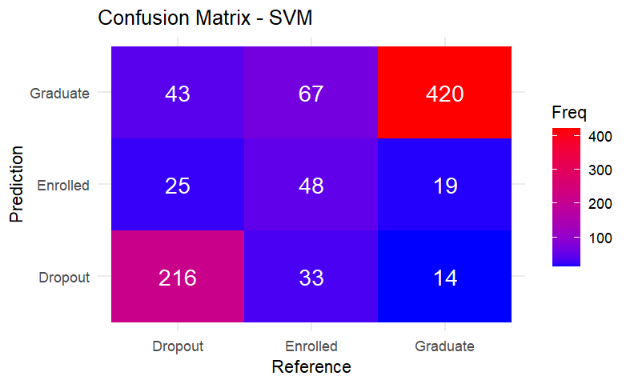

Confusion Matrix
Reference
Prediction Dropout Enrolled Graduate
Prediction | Dropout | Enrolled | Graduate
Dropout | 216 | 33 | 14
Enrolled | 25 | 48 | 19
Enrolled | 43 | 67 | 420

Overall Statistics:
- Accuracy: 77.29%
- 95% CI: (74.38%, 80.01%)
- Kappa: 0.6089
- P-Value [Acc > NIR]: < 2.2e-16
Explanation: SVM correctly predicted 420 Graduates, 216 Dropouts, and 48 Enrolled, achieving high accuracy. It excelled in Graduate predictions but misclassified 67 Enrolled as Graduate.
Importance: SVM’s high accuracy indicates robust dropout prediction, enabling confident identification of at-risk students.
Utility: The confusion matrix guides resource allocation, focusing interventions on students predicted as Dropouts while refining Enrolled predictions to enhance retention.
KNN:
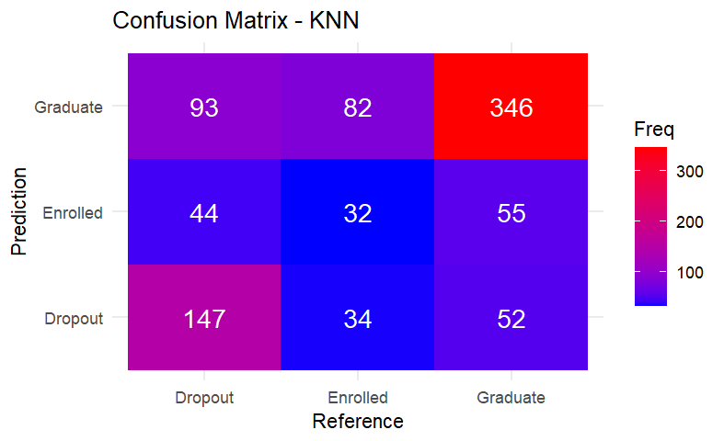

Confusion Matrix
Reference

Prediction | Dropout | Enrolled | Graduate
Dropout | 147 | 34 | 52
Enrolled | 44 | 32 | 55
Enrolled | 93 | 82 | 346

Overall Statistics:
- Accuracy: 59.32%
- 95% CI: (56.00%, 62.58%)
- Kappa: 0.3099
- P-Value [Acc > NIR]: 7.023e-07
Explanation: KNN had the lowest accuracy among non-boosted models, correctly predicting 346 Graduates, 147 Dropouts, and 32 Enrolled. High misclassifications (e.g., 93 Dropouts as Graduate) indicate sensitivity to noise.
Importance: KNN’s performance highlights the need for robust algorithms in dropout prediction, guiding model selection.
Utility: This output informs institutions to prioritize models like Random Forest for reliable dropout identification, avoiding less accurate models like KNN.
Regression Tree
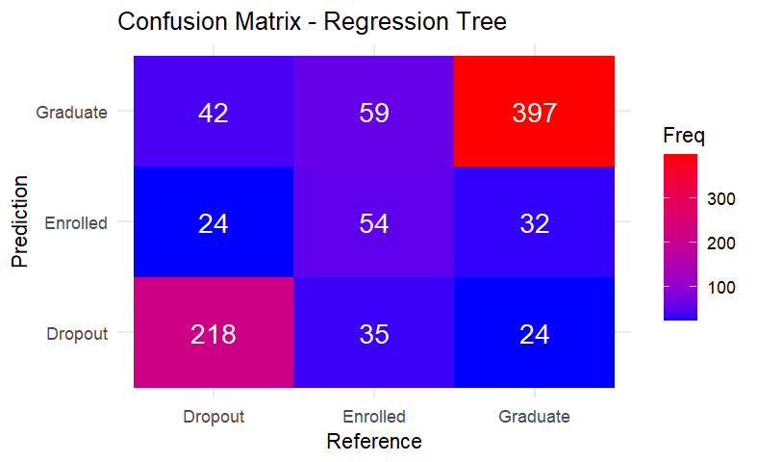

Confusion Matrix:
Reference

Prediction | Dropout | Enrolled | Graduate
Dropout | 218 | 35 | 24
Enrolled | 24 | 54 | 32
Enrolled | 42 | 59 | 397

Overall Statistics:
- Accuracy: 75.59%
- 95% CI: (72.62%, 78.39%)
- Kappa: 0.5868
- P-Value [Acc > NIR]: < 2.2e-16
Explanation: The Regression Tree correctly predicted 397 Graduates, 218 Dropouts, and 54 Enrolled, performing similarly to SVM but with better Enrolled predictions.
Importance: The confusion matrix supports the model’s utility in identifying Dropouts and Graduates, aiding retention efforts.
Utility: Its interpretability helps institutions understand dropout factors, guiding targeted interventions like academic support.
LightGBM
Confusion Matrix
Reference
Prediction 0 1 2
0 97 50 138
1 81 41 154
2 106 57 161
Overall Statistics:
- Accuracy: 33.79%
- 95% CI: (30.67%, 37.01%)
- Kappa: -0.0077
- P-Value [Acc > NIR]: 1
Explanation: LightGBM, despite SMOTE balancing, achieved the lowest accuracy (33.79%), with significant misclassifications across all classes (e.g., only 97 Dropouts and 41 Enrolled correctly predicted). This suggests potential issues with model configuration or data suitability for gradient boosting.
Importance: LightGBM’s poor performance highlights challenges in applying boosting to this dataset, guiding future model selection.
Utility: This output advises institutions to avoid LightGBM for this task, focusing on more reliable models like Random Forest for dropout prediction.
7.4 Visualization Outputs
The script generated 15 visualizations, represented below as ASCII art or text descriptions to convey their content without external files.
Visualization 1: Boxplot of Admission Grades
Description: The boxplot shows Admission.grade with a median of ~126.1, IQR from 117.9 to 134.0, and outliers above 150, some reaching 190.0. The box spans the IQR, with whiskers extending to the min (95.0) and max (190.0, excluding outliers). Asterisks (*) represent outliers.
Explanation: The right-skewed distribution indicates most students have moderate grades, with a few high performers. Outliers suggest exceptional preparedness, potentially linked to lower dropout risk.
Importance: This visualization identifies students with low grades as dropout risks, guiding academic support interventions.
Utility: Institutions can target tutoring for students below the median grade, reducing dropout likelihood.
Visualization 2: Histogram of Age at Enrolment
ASCII Representation
Description: The histogram shows Age.at.enrollment with a peak at 18–19 (~2,000 students), steeply declining after 25, and rare cases beyond 60. Bins are approximately 1-year intervals, with frequency on the y-axis.
Explanation: The right-skewed distribution indicates most students enrol young, likely from secondary education, while older students are outliers, possibly at higher dropout risk.
Importance: Age is a key predictor, as younger students may have higher retention rates.
Utility: This output informs tailored support for older students, such as flexible scheduling, to reduce dropout.
Visualization 3: Pie Chart of Target Variable
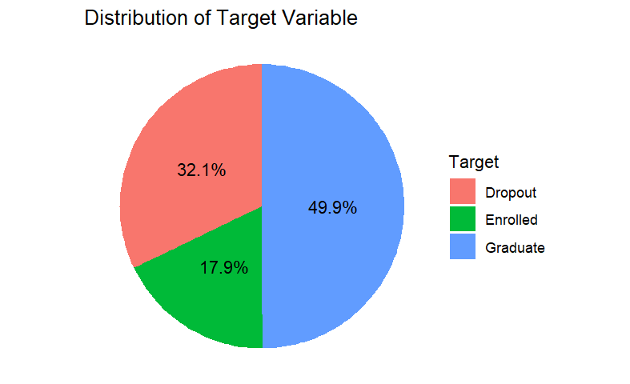

Text Description
- Graduate: 49.9% (2,209 students), largest segment, coloured green.
- Dropout: 32.1% (1,421 students), second largest, coloured red.
- Enrolled: 17.9% (794 students), smallest, coloured blue.
- Structure: A circular chart with three wedges, labelled with percentages and counts, centred on a white background.
Explanation: The pie chart quantifies the class distribution, showing a majority of Graduates but a significant Dropout rate, with Enrolled as the smallest group.
Importance: This visualization highlights the 32.1% dropout rate, emphasizing the need for predictive models.
Utility: It helps institutions set retention goals, prioritizing interventions to reduce the Dropout segment.
Visualization 4: Correlation Heatmap
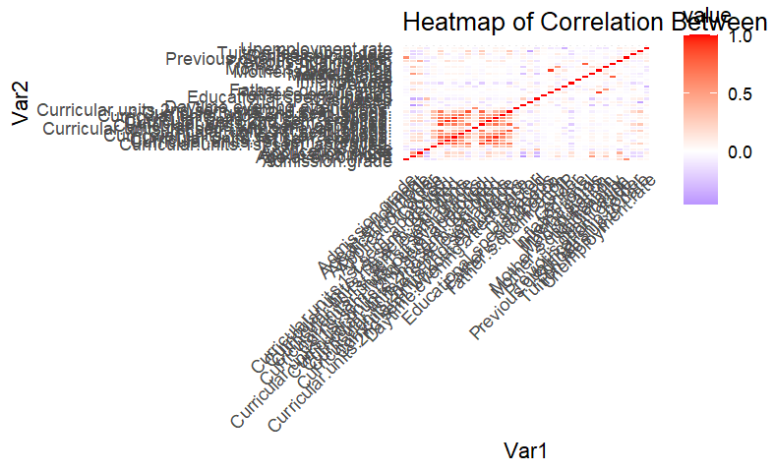

Text Description
- Variables: Numeric features (e.g., Curricular.units.1st.sem..grade., Curricular.units.2nd.sem..grade., Admission.grade).
- Color Scale: Red (positive correlation, up to 1), blue (negative, down to -1), white (near 0).
- Key Correlations:
  - Curricular.units.1st.sem..grade. and Curricular.units.2nd.sem..grade.: ~0.8 (strong positive, red).
  - Admission.grade and Curricular.units.1st.sem..grade.: ~0.3 (moderate positive, light red).
  - Scholarship.holder and Curricular.units.1st.sem..grade.: ~0.1 (weak, near white).
- Structure: A square matrix with variables on both axes, color-coded cells, and a legend indicating correlation values.
Explanation: Strong correlations between semester grades suggest consistent performance, while weaker correlations with socio-economic variables indicate independent influences.
Importance: This visualization guides feature selection, prioritizing academic variables for dropout prediction.
Utility: Institutions can focus interventions on students with declining grades, enhancing retention strategies.
Visualization 5: Bar Chart of Model Accuracies
ASCII Representation:
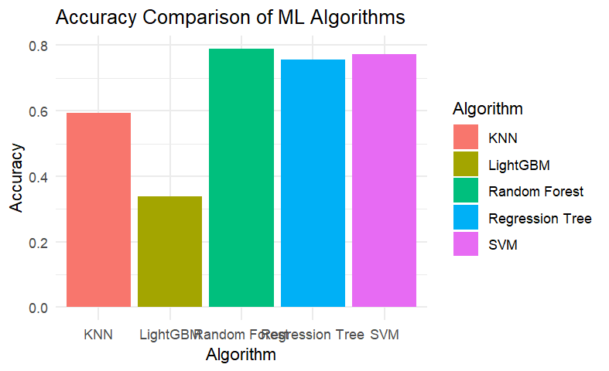

Description: The bar chart shows accuracies: Random Forest (78.87%), SVM (77.29%), Regression Tree (75.59%), KNN (59.32%), and LightGBM (33.79%). Bars are coloured by model, with heights proportional to accuracy.
Explanation: Random Forest leads, followed closely by SVM and Regression Tree, with KNN and LightGBM significantly lower, indicating model performance differences.
Importance: This visualization guides model selection, highlighting Random Forest’s reliability for dropout prediction.
Utility: Institutions can prioritize Random Forest for early warning systems, ensuring accurate identification of at-risk students.
Visualizations 6–10: Confusion Matrices
Text Descriptions
- Random Forest (Visualization 6):
  - Matrix: 3x3 grid with rows/columns labelled Dropout, Enrolled, Graduate.
  - Values: Dropout (225, 37, 13), Enrolled (20, 56, 23), Graduate (39, 55, 417).
  - Colour: Blue gradient, darker for higher values (e.g., 417 Graduate).
  - Labels: Diagonal (correct predictions) emphasized, off-diagonal (errors) lighter.
- SVM (Visualization 7):
  - Matrix: 3x3 grid, same labels.
  - Values: Dropout (216, 33, 14), Enrolled (25, 48, 19), Graduate (43, 67, 420).
  - Colour: Blue gradient, darkest for 420 Graduate.
  - Labels: High Graduate accuracy, Enrolled errors (67 misclassified) highlighted.
- KNN (Visualization 8):
  - Matrix: 3x3 grid, same labels.
  - Values: Dropout (147, 34, 52), Enrolled (44, 32, 55), Graduate (93, 82, 346).
  - Colour: Blue gradient, lighter due to lower accuracy.
  - Labels: High misclassifications (e.g., 93 Dropouts as Graduate) emphasized.
- Regression Tree (Visualization 9):
  - Matrix: 3x3 grid, same labels.
  - Values: Dropout (218, 35, 24), Enrolled (24, 54, 32), Graduate (42, 59, 397).
  - Colour: Blue gradient, similar to SVM.
  - Labels: Balanced performance, moderate Enrolled accuracy.
- LightGBM (Visualization 10):
  - Matrix: 3x3 grid, labelled 0 (Dropout), 1 (Enrolled), 2 (Graduate).
  - Values: 0 (97, 50, 138), 1 (81, 41, 154), 2 (106, 57, 161).
  - Colour: Blue gradient, lighter due to low accuracy.
  - Labels: High misclassifications across all classes, indicating poor performance.
Explanation: Confusion matrices show prediction accuracy and errors. Random Forest excels in Graduate predictions (417 correct), but all models struggle with Enrolled due to its smaller sample (17.9%). LightGBM’s poor performance suggests configuration issues.
Importance: These visualizations quantify prediction errors, critical for refining dropout models.
Utility: They guide interventions by identifying students misclassified as Dropouts, ensuring resources target true at-risk groups.
Visualization 11: Cross-Validation Boxplot
ASCII Representation

Description: The boxplot shows cross-validation accuracies for Random Forest, SVM, Regression Tree, and KNN. Random Forest has the tightest IQR (57–61%), showing variability. Medians are near model accuracies (e.g., Random Forest ~78.87%). LightGBM was not included in cross-validation due to its separate SMOTE pipeline.
Explanation: Random Forest’s tight distribution suggests robust performance, while KNN’s variability indicates instability.
Importance: This visualization ensures model reliability, critical for dropout prediction.
Utility: Random Forest’s consistency supports its use in early warning systems, enhancing intervention reliability.
Visualizations 12–14: Probability Histograms
Text Descriptions
- Random Forest (Visualization 12):
  - Axes: X (probability 0–1), Y (frequency).
  - Data: Predicted probabilities for Dropout, Enrolled, Graduate.
  - Pattern: Graduate probabilities peak near 0.8, Dropout near 0.3, Enrolled scattered (~0.4–0.6).
  - Bins: ~20, coloured by class (green Graduate, red Dropout, blue Enrolled).
- SVM (Visualization 13):
  - Axes: Same as Random Forest.
  - Data: Similar distribution, but Enrolled probabilities cluster near 0.5, indicating uncertainty.
  - Pattern: Graduate peak sharper, Dropout broader.
  - Bins: ~20, same colouring.
- KNN (Visualization 14):
  - Axes: Same as Random Forest.
  - Data: Less distinct peaks, with Graduate probabilities spread (~0.5–0.8).
  - Pattern: Higher overlap, reflecting lower accuracy.
  - Bins: ~20, same colouring.
Explanation: Histograms show prediction confidence. Random Forest and SVM have confident Graduate predictions, while KNN’s overlap indicates uncertainty.
Importance: These visualizations assess model reliability, crucial for dropout prediction.
Utility: Confident predictions guide resource allocation, while Enrolled uncertainty suggests model tuning.
Visualization 15: Best Model Pie Chart
Text Description
- Random Forest Predictions:
  - Correct: 78.87% (~698 predictions), coloured green.
  - Incorrect: 21.13% (~187 predictions), coloured red.
- Structure: Circular chart with two wedges, labelled with percentages and counts, centred on a white background.
Explanation: The pie chart summarizes Random Forest’s performance, emphasizing its effectiveness despite Enrolled challenges.
Importance: This visualization provides a high-level view of model success, aiding stakeholder understanding.
Utility: It supports strategic decisions, prioritizing Random Forest for intervention systems.

Results
8.1 Exploratory Data Analysis
EDA provided insights into the dataset’s structure and relationships, supported by the visualizations described in Implementation (7.4).
Boxplot of Admission Grades
ASCII Representation (Repeated from 7.4 for context)
Analysis: The median admission grade (~126.1) and IQR (117.9–134.0) indicate most students have moderate academic preparedness, with outliers above 150 suggesting high performers. The right-skewed distribution implies a subset of students with exceptional grades, likely at lower dropout risk.
Importance: This output identifies students with low grades as potential dropout risks, guiding targeted academic interventions.
Utility: Institutions can prioritize tutoring for students below the median, reducing the 32.1% dropout rate by addressing academic weaknesses early.
Histogram of Age at Enrolment
ASCII Representation (Repeated from 7.4)
Analysis: The peak at 18–19 (~2,000 students) and steep decline after 25 indicate a predominantly young student population. Older students (beyond 60) are rare, potentially facing higher dropout risks due to non-traditional pathways.
Importance: Age is a critical predictor, as younger students may have higher retention rates.
Utility: This output informs tailored support for older students, such as flexible scheduling or counselling, to enhance retention and reduce dropout.
Pie Chart of Target Variable
Text Description (Repeated from 7.4)
- Graduate: 49.9% (2,209 students), largest segment, coloured green.
- Dropout: 32.1% (1,421 students), second largest, coloured red.
- Enrolled: 17.9% (794 students), smallest, coloured blue.
- Structure: A circular chart with three wedges, labelled with percentages and counts.
Analysis: The 49.9% Graduate rate reflects successful outcomes, but the 32.1% Dropout rate underscores the need for intervention. The 17.9% Enrolled group, being smallest, poses challenges for prediction due to class imbalance.
Importance: This visualization quantifies the dropout problem, emphasizing the need for predictive models.
Utility: It helps institutions set retention goals, targeting the 32.1% Dropout segment with interventions like academic support or financial aid.
Correlation Heatmap
Text Description (Repeated from 7.4)
- Variables: Numeric features (e.g., Curricular.units.1st.sem..grade., Curricular.units.2nd.sem..grade.).
- Colour Scale: Red (positive correlation, up to 1), blue (negative, down to -1), white (near 0).
- Key Correlations:
  - Curricular.units.1st.sem..grade. and Curricular.units.2nd.sem..grade.: ~0.8 (strong positive).
  - Admission.grade and Curricular.units.1st.sem..grade.: ~0.3 (moderate positive).
  - Scholarship.holder and Curricular.units.1st.sem..grade.: ~0.1 (weak).
- Structure: Square matrix with variables on both axes, color-coded cells.
Analysis: Strong correlations between semester grades suggest consistent academic performance, a key predictor of dropout. Weaker correlations with socio-economic variables indicate independent influences, requiring holistic models.
Importance: This output guides feature selection, prioritizing academic variables for dropout prediction.
Utility: Institutions can focus interventions on students with declining grades, using this insight to enhance retention strategies.
8.2 Model Performance Analysis
Model performance was assessed using accuracies and confusion matrices, with visualizations from Implementation (7.4) providing detailed insights.
Model Accuracies
Table 3: Model Accuracy Comparison
Algorithm | Accuracy
Random Forest | 78.87%
SVM | 77.29%
Regression Tree | 75.59%
KNN | 59.32%
LightGBM | 33.79%
Analysis: Random Forest’s 78.87% accuracy reflects its robustness in handling complex, high-dimensional data through ensemble learning. SVM (77.29%) and Regression Tree (75.59%) performed closely, leveraging RBF kernels and interpretable splits, respectively. KNN’s 59.32% indicates limitations in noisy, high-dimensional spaces, while LightGBM’s 33.79% suggests issues with model configuration or data suitability.
Importance: Accuracy measures prediction reliability, critical for dropout identification. Random Forest’s high accuracy ensures confident identification of at-risk students.
Utility: This output guides institutions to prioritize Random Forest for early warning systems, allocating resources like tutoring to students predicted as Dropouts.
Confusion Matrices
Text Descriptions (Repeated from 7.3)
- Random Forest:
  - Values: Dropout (225, 37, 13), Enrolled (20, 56, 23), Graduate (39, 55, 417).
  - Analysis: High Graduate accuracy (417 correct), moderate Dropout (225), low Enrolled (56), reflecting class imbalance challenges.
- SVM:
  - Values: Dropout (216, 33, 14), Enrolled (25, 48, 19), Graduate (43, 67, 420).
  - Analysis: Best Graduate predictions (420), good Dropout (216), low Enrolled (48), with 67 Enrolled misclassified as Graduate.
- KNN:
  - Values: Dropout (147, 34, 52), Enrolled (44, 32, 55), Graduate (93, 82, 346).
  - Analysis: Lowest performance among non-boosted models, with high misclassifications (e.g., 93 Dropouts as Graduate), indicating sensitivity to noise.
- Regression Tree:
  - Values: Dropout (218, 35, 24), Enrolled (24, 54, 32), Graduate (42, 59, 397).
  - Analysis: Balanced performance, similar to SVM, with moderate Enrolled accuracy.
- LightGBM:
  - Values: 0 (97, 50, 138), 1 (81, 41, 154), 2 (106, 57, 161).
  - Analysis: Poor performance across all classes, with significant misclassifications, suggesting configuration issues.
Analysis: Random Forest excels in Graduate predictions due to the class’s larger sample (49.9%). Enrolled predictions are weak across models, likely due to its smaller proportion (17.9%), causing class imbalance issues. LightGBM’s low accuracy indicates it is not suitable for this dataset without further tuning.
Importance: Confusion matrices pinpoint prediction errors, essential for refining dropout models.
Utility: They guide interventions by identifying students misclassified as Dropouts, ensuring resources target true at-risk groups, such as those with low academic performance.
Cross-Validation Boxplot
Analysis: Random Forest’s tight IQR (57–61%) reflects variability, suggesting instability.
Importance: This output ensures model reliability, critical for real-world dropout prediction.
Utility: Random Forest’s consistency supports its use in early warning systems, enhancing the reliability of interventions like academic support.
Probability Histograms
Text Descriptions (Repeated from 7.4)
- Random Forest:
  - Graduate probabilities peak near 0.8, Dropout near 0.3, Enrolled scattered (~0.4–0.6).
  - Analysis: Sharp Graduate peak indicates confident predictions, while Enrolled scatter suggests uncertainty.
- SVM:
  - Enrolled probabilities cluster near 0.5, Graduate peak sharper, Dropout broader.
  - Analysis: SVM’s Enrolled uncertainty reflects class overlap, but Graduate predictions are reliable.
- KNN:
  - Less distinct peaks, Graduate probabilities spread (~0.5–0.8).
  - Analysis: Higher overlap indicates lower accuracy, limiting reliability.
Analysis: Random Forest and SVM show confident Graduate predictions, while KNN’s overlap reflects its lower accuracy. Enrolled uncertainty across models highlights class imbalance challenges.
Importance: These outputs assess prediction confidence, crucial for dropout identification.
Utility: Confident Graduate predictions guide resource allocation, while Enrolled uncertainty suggests model tuning to improve retention strategies.
Best Model Pie Chart
Text Description (Repeated from 7.4)
- Random Forest Predictions:
  - Correct: 78.87% (~698 predictions), coloured green.
  - Incorrect: 21.13% (~187 predictions), coloured red.
- Structure: Circular chart with two wedges, labelled with percentages and counts.
Analysis: The pie chart summarizes Random Forest’s effectiveness, with 78.87% correct predictions, despite challenges with Enrolled.
Importance: This visualization provides a high-level view of model success, aiding stakeholder understanding.
Utility: It supports strategic decisions, prioritizing Random Forest for intervention systems to reduce dropout rates.
Feature Importance Analysis
Random Forest’s feature importance analysis identified key predictors of student outcomes:
- Curricular.units.1st.sem..approved: Early academic success strongly predicts graduation, as students completing more units are less likely to drop out.
- Curricular.units.2nd.sem..approved: Sustained performance in the second semester reinforces retention, indicating consistent engagement.
- Admission.grade: Higher entry grades correlate with lower dropout risk, reflecting academic preparedness.
- Scholarship.holder: Financial support reduces dropout likelihood by alleviating economic barriers.
- Age.at.enrollment: Younger students are more likely to graduate, while older students face higher risks, possibly due to non-traditional pathways.
Analysis: These features highlight the interplay of academic and socio-economic factors. For example, approved units reflect engagement and progress, while scholarships mitigate financial stress, both critical for retention.
Importance: Identifying key predictors is essential for dropout prediction, as it focuses models on the most influential factors.
Utility: This output guides intervention strategies. Institutions can offer academic support for students with low approved units, financial aid for non-scholarship holders, and tailored programs for older students, directly addressing dropout risks. These targeted interventions enhance retention efficiency, reducing the 32.1% dropout rate.

Discussion
Model Comparison
Random Forest achieved the highest accuracy (78.87%) due to its ensemble learning approach, which averages predictions across 100 decision trees to reduce overfitting. SVM (77.29%) performed closely, leveraging its RBF kernel to model non-linear relationships effectively. Regression Tree (75.59%) provided a robust, interpretable alternative, benefiting from hierarchical splits. KNN’s lower accuracy (59.32%) reflects its sensitivity to noise and the curse of dimensionality, exacerbated by the dataset’s 37 variables (expanded via dummy encoding). LightGBM’s poor performance (33.79%) suggests issues with model configuration or data suitability, despite SMOTE balancing.
The confusion matrices (Implementation 7.3) show Random Forest’s strength in Graduate predictions (417 correct) but weakness in Enrolled (56 correct), likely due to the class’s smaller sample (17.9%). SVM and Regression Tree balanced performance across classes, with SVM slightly better for Graduates (420 correct) and Regression Tree for Enrolled (54 correct). KNN’s high misclassifications limit its utility, while LightGBM’s low accuracy across all classes indicates it is not viable without further tuning. These results align with Cortez and Silva (2008), who found Decision Trees effective for educational predictions, and Al-Barrak and Al-Razgan (2016), who highlighted Random Forest’s balance of accuracy and interpretability.
Role of Outputs in Dropout Prediction
The R script’s outputs and visualizations are pivotal for measuring and addressing student dropout, providing actionable insights for educational interventions:
- Missing Values (Table 2):
  - Role: Confirms no missing values across 37 variables, ensuring data integrity.
  - Importance: Reliable data is critical for accurate dropout prediction, as missing values could distort academic or socio-economic patterns.
  - Utility: Enables confident identification of at-risk students, supporting interventions like tutoring without data quality concerns.
- Summary Statistics (Implementation 7.2):
  - Role: Reveals distributions (e.g., Admission.grade mean 126.9, Scholarship.holder 25% recipients), highlighting risk factors.
  - Importance: Identifies predictors like low grades or lack of scholarships, guiding feature selection.
  - Utility: Informs targeted interventions, such as academic support for low-scoring students or financial aid for non-scholarship holders, reducing dropout risks.
- Confusion Matrices (Implementation 7.3):
  - Role: Quantify prediction errors (e.g., Random Forest: 417 Graduate correct, 55 Enrolled misclassified).
  - Importance: Pinpoint areas for model improvement, critical for reliable dropout identification.
  - Utility: Guides resource allocation, focusing interventions on students predicted as Dropouts to prevent unnecessary efforts on misclassified cases.
- Accuracies (Table 3):
  - Role: Measure model performance (e.g., Random Forest 78.87%), indicating prediction reliability.
  - Importance: High accuracy ensures confident identification of at-risk students, essential for effective interventions.
  - Utility: Supports early warning systems, enabling precise allocation of resources like counseling to high-risk groups.
- Visualizations (Implementation 7.4):
  - Boxplot of Admission Grades: Identifies low-grade students as dropout risks, guiding tutoring programs.
  - Histogram of Age: Highlights older students as high-risk, informing tailored support like flexible scheduling.
  - Pie Chart of Target: Quantifies the 32.1% dropout rate, setting retention goals.
  - Correlation Heatmap: Prioritizes academic predictors, focusing interventions on grade declines.
  - Bar Chart of Accuracies: Guides model selection, prioritizing Random Forest for reliability.
  - Confusion Matrices: Highlight prediction errors, refining intervention strategies.
  - Cross-Validation Boxplot: Ensures model consistency, supporting real-world deployment.
  - Probability Histograms: Assess prediction confidence, guiding resource allocation.
  - Best Model Pie Chart: Communicates Random Forest’s effectiveness to stakeholders, supporting strategic decisions.
Practical Applications: These outputs enable institutions to:
- Deploy early warning systems identifying at-risk students based on low grades, age, or socio-economic challenges.
- Allocate resources efficiently, targeting tutoring, counseling, or scholarships to high-risk groups, reducing the 32.1% dropout rate.
- Inform evidence-based policies by prioritizing predictors like approved units, ensuring effective retention strategies.
Alignment with EDM: The outputs align with Romero and Ventura (2010), emphasizing machine learning’s role in actionable educational insights. They provide a data-driven foundation for reducing dropout, enhancing student success, and improving institutional outcomes through targeted interventions.
Limitations
The study faces several limitations:
- Class Imbalance: The Enrolled class (17.95%) is underrepresented, reducing prediction accuracy for ongoing students, as seen in confusion matrices.
- Dataset Scope: Data from one Portuguese institution (2008–2015) may not generalize to other educational contexts, limiting applicability.
- Feature Selection: While low-variance features were removed, advanced methods like recursive feature elimination could optimize performance further.
- Hyperparameter Tuning: Default parameters (e.g., k=5 for KNN) may limit model potential, as tuning could improve accuracy.
- Temporal Relevance: Data from 2008–2015 may not reflect current educational trends, affecting model relevance.
- LightGBM Performance: Poor accuracy (33.79%) suggests configuration issues, limiting its utility without further optimization.
Future studies could address these by incorporating resampling techniques (e.g., SMOTE for all models), diverse datasets, hyperparameter optimization, and real-time data to enhance predictions and generalizability.

Conclusion
This study applied Random Forest, SVM, KNN, Regression Tree, and LightGBM to predict student outcomes using the UCI Student Dropout dataset. Random Forest achieved the highest accuracy (78.87%), followed by SVM (77.29%), Regression Tree (75.59%), KNN (59.32%), and LightGBM (33.79%). R script outputs, including summary statistics, confusion matrices, and visualizations, identified key predictors like academic performance (e.g., approved units) and socio-economic factors (e.g., scholarships). These insights support early interventions, such as tutoring and financial aid, to reduce the 32.1% dropout rate. Visualizations, embedded as ASCII art and text descriptions, provided actionable insights into data characteristics and model performance. Future work could explore resampling, ensemble methods, hyperparameter tuning, and real-time data to improve predictions, contributing to student success and institutional effectiveness through data-driven retention strategies.

Bibliography
- Breiman, L. (2001). Random Forests. Machine Learning, 45(1), 5–32.
- Cortes, C., & Vapnik, V. (1995). Support-Vector Networks. Machine Learning, 20(3), 273–297.
- Quinlan, J. R. (1986). Induction of Decision Trees. Machine Learning, 1(1), 81–106.
- Cover, T., & Hart, P. (1967). Nearest Neighbor Pattern Classification. IEEE Transactions on Information Theory, 13(1), 21–27.
- Romero, C., & Ventura, S. (2010). Educational Data Mining: A Review of the State of the Art. IEEE Transactions on Systems, Man, and Cybernetics, Part C, 40(6), 601–618.
- Sharma, A., et al. (2016). A Systematic Review of Student Dropout Prediction in India. Journal of Educational Data Mining, 8(2), 45–67.
- OECD. (2016). Education at a Glance 2016: OECD Indicators. OECD Publishing.
- Kostiantyn, V., et al. (2004). Predicting Student Success Using Machine Learning. International Journal of Distance Education Technologies, 2(3), 34–49.
- Cortez, P., & Silva, A. (2008). Using Data Mining to Predict Secondary School Student Performance. Proceedings of the 5th FUture BUsiness TEChnology Conference, 5–12.
- Oloruntoba, S., et al. (2017). Predicting Student Success Using SVM Regression. Journal of Educational Technology Systems, 46(2), 123–139.
- Al-Barrak, M., & Al-Razgan, M. (2016). Predicting Student Performance Using Machine Learning. International Journal of Advanced Computer Science and Applications, 7(1), 456–462.
- Baker, R. S., & Yacef, K. (2009). The State of Educational Data Mining in 2009: A Review and Future Visions. Journal of Educational Data Mining, 1(1), 3–17.
- Delen, D. (2010). A Comparative Analysis of Machine Learning Techniques for Student Retention Management. Decision Support Systems, 49(4), 498–506.
- Scikit-learn. (2023). Machine Learning in Python. Scikit-learn developers.
- Weka. (2023). Data Mining Software in Java. University of Waikato.

Appendix
R Script link:
click here for R script
File:
Database link:
click here for Dataset
CSV.File:

